

|  |  |
| --- | --- |
| **STUDENT NAME** | **Abdullah Muhammad Ibrahim** |
| **STUDENT ID** | **SP20-BSCS-0027** |
| **SECTION** | **AM** |
| **ASSIGNMENT NO.** | **05** |
| **DUE DATE** | **Nov 12, 11:59 PM** |
| **SUBMITTED ON** | **Nov 12, 2020** |

**Question 1/Task 1:**

**Make a class named ‘Courses’. While creating an object of the class, if nothing is**

**passed to it, then the message “I am not enrolled in any course yet” should be**

**displayed. If some course name(s) is/are passed to it, then in place of “I am not**

**enrolled in any course yet” the name(s) of the courses should be displayed.**

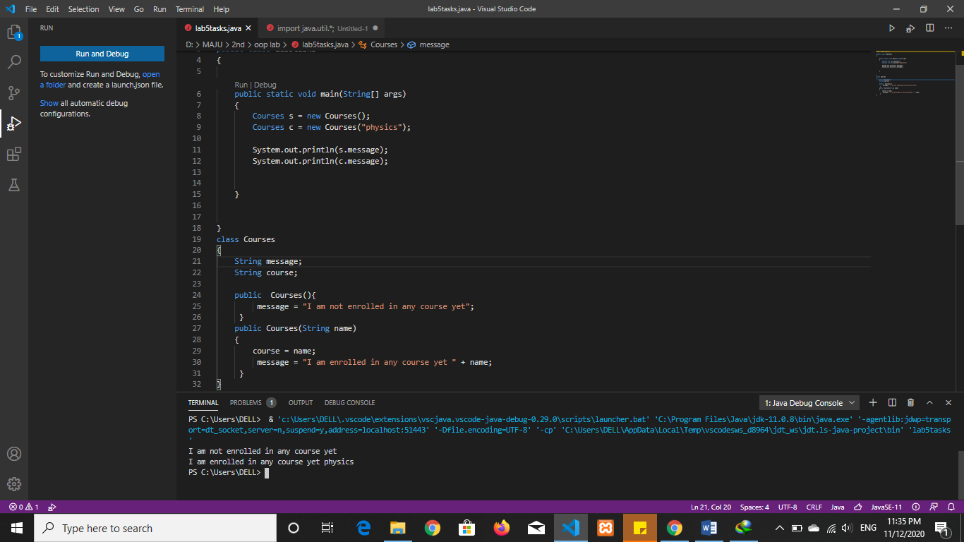

**Question 2/Task 2:**

**Make a class named Rectangle having two data members, length and breadth and**

**a method area () for calculating the area.**

**The following three constructors should be there in your class:**

**a. No args/parameter less constructor: Length and breadth values should be**

**assigned zero.**

**b. Parameterized constructor (1 parameter): Length and breadth values should be**

**same.**

**c. Parameterized constructor (2 parameters): Length and breadth values should be**

**assigned by 2 parameters respectively.**

**By using the concept of object array, create 3 objects of the Rectangle class having**

**none, one and two arguments and print their areas.**

